**POLYTECHNIC UNIVERSITY OF THE PHILIPPINES**

**COLLEGE OF COMPUTER AND INFORMATION SCIENCES**

Sta. Mesa, Manila

**KALINGA: A Network Plan for a Pet Adoption Center**

By

**Bosi, Idan Josh**

**Cayabyab, Jeremy Jhay**

**Murillo, Malcolm James**

**Taylo, Kirsten Kyla**

**2024**

**ACKNOWLEDGEMENT**

We would like to express our deepest gratitude to everyone who has supported and guided us throughout the development of this network plan for the KALINGA Pet Adoption Center. This project would not have been possible without the contributions and encouragement of many individuals and organizations.First and foremost, we are immensely grateful to our advisor, Sir Carlo Inovero, for his invaluable guidance, continuous support, and constructive feedback throughout this project. Their expertise and dedication were instrumental in shaping our ideas and ensuring the successful completion of this plan. We also extend our heartfelt thanks to the faculty members of the College of Computer and Information Sciences at the Polytechnic University of the Philippines for providing us with the necessary knowledge and resources. Their teachings and insights have been foundational to our understanding and execution of this project. We are also thankful to the KALINGA Pet Adoption Center for allowing us to work on this meaningful project. Their cooperation and the information they provided were crucial in understanding the real-world challenges and requirements of the network infrastructure.

Our sincere appreciation goes to our families and friends for their unwavering support and encouragement. Their patience and understanding during the long hours of work and study have been our source of strength. Lastly, we would like to acknowledge our team members for their hard work, dedication, and teamwork. Each member's unique skills and perspectives have been vital to the successful development of this network plan. Thank you all for your invaluable contributions.

**ABSTRACT OF THE PROJECT PROPOSAL**

**Project Description**

**1.1. Objectives**

**1.1.1. General Objective**

* To strengthen the network and resources available for animal rescue and welfare.
* To enhance resource sharing and collaboration among the networks.
* To design and implement a secure and scalable network infrastructure

**1.1.2. Specific Objective**

* Design a hierarchical network with redundancy, VLANs, inter-VLAN routing, and secure communications.
* Implement Access Control Lists (ACLs) and Virtual Private Networks (VPNs).
* Configure dynamic and static IP addressing, OSPF routing, SSH access, and Port Security.
* Ensure network security and performance and verify end-to-end connectivity.

**1.2. Scope and Limitation**

The project involves designing and implementing a network for a pet adoption center with three branches using Cisco Packet Tracer. The network will use a hierarchical model for redundancy, with core and branch routers connected via serial connections. Each department will have unique VLANs and subnets, along with wireless networks. Basic device settings will be configured, and IP addresses will be dynamically assigned by DHCP servers, with static IPs for server room devices. OSPF will be used for routing, and multilayer switches will handle inter-VLAN routing. Security features include SSH for remote access, port security, and an extended ACL rule with site-to-site IPSec VPN for encrypted communication. PAT will be configured for NAT, and thorough testing will ensure proper functionality. The project is limited to simulation using Cisco Packet Tracer, which may not capture all real-world issues. The design supports a specific number of users (60 at HQ and 30 at branches per department) and may need adjustments for different sizes. It relies on static public IPs, which may change. While security features are implemented, not all potential threats are covered. The design uses specific Cisco hardware, which may not be accessible everywhere. The project does not address potential limitations in device resources or include ongoing maintenance and user training.

**1.3. Statement of the Problem(s)**

The pet adoption center is facing significant operational inefficiencies and client dissatisfaction, which can be attributed to the inadequate network infrastructure and communication systems currently in place (Dumas & Redish, 1999). These issues are impacting the center's ability to provide timely and effective services to clients and ensure the well-being of the pets in their care.

Below are some reviews that highlight the challenges faced by clients:

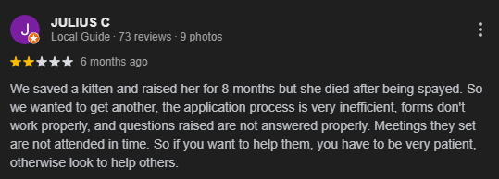

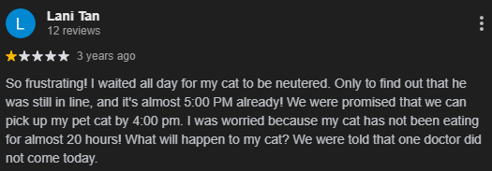

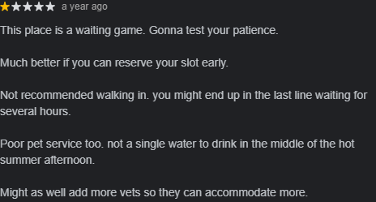

These reviews exemplify the specific problems, which include:

1. Inefficient Scheduling System: The lack of real-time integration causes long wait times and overbooked appointments, leading to client frustration.
2. Poor Communication and Coordination: Absence of a unified platform results in ineffective internal and client communication, causing unmet expectations.
3. Inadequate Client Information Management: Fragmented systems delay adoption processing and inquiries due to lack of a centralized database.
4. Insufficient Resource Allocation: Inefficient allocation of veterinary staff and resources during peak times causes prolonged wait times and unmet demand.

**1.4. Proposed Solution(s)**

To address the operational inefficiencies and client dissatisfaction at the pet adoption center, which has three branches, we propose a comprehensive upgrade of the network infrastructure. This solution includes implementing a hierarchical network design with core, distribution, and access layers to ensure smooth data flow and scalability. We will configure Virtual LANs (VLANs) to segment network traffic based on department functions, enhancing performance and security. Secure Virtual Private Networks (VPNs) will be established to enable encrypted communication between branches and provide remote access for staff. The Open Shortest Path First (OSPF) routing protocol will manage dynamic routing between branches, ensuring optimal path selection and reliable connectivity. Access Control Lists (ACLs) and port security measures will enhance network security by regulating traffic and preventing unauthorized access. A centralized network management system will monitor and manage the entire infrastructure, providing real-time insights and efficient resource allocation. This proposed network solution will streamline operations, improve client satisfaction, and ensure the well-being of pets by addressing core issues in scheduling, communication, information management, and resource allocation across all three branches.

**1.5. Activity Plan**

**1.5.1. Planned Activities**

1. Concept Planning

* Define the goals and scope of the network.
* Describe the establishment and its primary functions.

1. Requirements Gathering

* Identify the number of users and types of devices
* Identify the applications and services that will run on the network such as email and file sharing.

1. Network Design

* Identify the network topology to be used.
* Create IP address ranges and subnetting.

1. Simulation on Cisco Packet Tracer

* Create the network topology in Cisco Packet Tracer.
* Configure devices such as routers and switches
* Run the simulation and resolve the issues encountered

1. Documentation

* Create detailed documentation for the network plan.

**1.5.2. Schedule of Activities and Tasking**

|  |  |  |  |
| --- | --- | --- | --- |
| **Tasks** | **Members** | **Start Date** | **End Date** |
| Concept Planning | All members | May 1, 2024 | May 4, 2024 |
| Concept Revision | Kirsten Kyla Taylo | May 20,2024 | May 24, 2024 |
| Requirements Gathering | Jeremy Jhay Cayabyab | May 27, 2024 | May 30, 2024 |
| Network Design | Idan Josh Bosi/Malcolm James Murillo | June 5, 2024 | June 22, 2024 |
| Simulation On Cisco Packet Tracer | Idan Josh Bosi/Malcolm James Murillo | June 22, 2024 | July 6, 2024 |
| Documentation | All members | June 27, 2024 | July 7, 2024 |

**Chapter 1 - ORGANIZATION ANALYSIS**

**History**

KALINGA was founded in 2022 by a group of passionate animal lovers who were determined to address the issue of homeless pets in their community. Initially, the center started as a small, volunteer-run shelter operating out of a rented facility. The founders organized adoption events, spay/neuter clinics, and community outreach programs to raise awareness about responsible pet ownership. The center received significant donations and grants, enabling it to purchase a larger property and expand its operations. This period marked the beginning of the center's growth into a well-established organization. They introduced more comprehensive veterinary services, behavioral training for pets, and a robust foster care program. Today, the KALINGA operates through a network of foster homes and community partners rather than a single, centralized facility. This decentralized approach allows the center to reach a wider range of animals and provide more personalized care. By leveraging technology, the center facilitates adoptions through an online platform, where potential adopters can meet pets virtually and complete the adoption process efficiently. The network model has also strengthened community engagement, with local businesses and volunteers actively supporting the center's mission.

**Vision**

The vision of the KALINGA is to create a world where every pet has a loving, permanent home. The center envisions a future where the number of homeless and neglected animals is significantly reduced through proactive measures such as widespread spay/neuter programs, educational initiatives, and strong community partnerships. By striving for this vision, KALINGA hopes to lead the way in transforming how society treats and values animals, ensuring a brighter and more humane future for all pets.

**Mission**

The mission of KALINGA is to rescue, rehabilitate, and rehome animals in need while promoting responsible pet ownership through education and community engagement. The center is dedicated to providing a safe haven for homeless pets, ensuring they receive the medical care, love, and attention they deserve. Through its efforts, the center aims to reduce the population of stray and abandoned animals and to foster a compassionate society that respects and cares for all animals

.

**Organizational units and its function**

1. **Administration** - It oversees the overall management of the pet adoption center, including staff coordination, financial planning, budgeting. It also ensures smooth day-to-day operations across all branches.
2. **Pet Care** - This organization is tasked with monitoring and maintaining the health and well-being of pets. This includes tracking medical records, administering vaccinations, providing routine and emergency care. It ensures that pets are receive proper nutrition and attention
3. **Adoption Services** - It manages the entire adoption process. This unit works closely with potential adopters to understand their needs and conducts thorough screening processes.
4. **Facilities Management** - This unit is in charge of maintaining the building’s infrastructure. It involves maintenance, ensuring cleanliness and safety standards are met, and keeping track of supply and equipment inventories.
5. **Customer Service** - This unit provides support and assistance to all visitors and potential adopters. They handle inquiries and ensure a positive experience for their customers.
6. **Legal and Compliance** - This unit ensures that the pet adoption center follows all relevant laws, regulations, and ethical standards. This includes managing legal documents and implementing policies to maintain compliance.
7. **Rescue and Logistics** - It manages pet transport for adoptions and rescue. This involves coordinating schedules, making sure that the transport is safe, and maintaining transportation vehicles and equipment.

**Information System**

|  |  |  |  |  |  |  |
| --- | --- | --- | --- | --- | --- | --- |
| **PET ADOPTION CENTER** | | | | | | |
| **Organizational**  **Units** | **Information Systems** | **Subsystems** | **Functions** | **User/s** | **Link System/Subsystem** | **Network-ed (Yes/No)** |
| Administration | Management Information System (MIS) | Human Resources, Finance, Admin | Manage staff, finances, and operations | Admin staff | HR, Finance, CRM | Yes |
| Pet Care | Pet Management System (PMS) | Animal Care, Health Records | Track pet health, vaccinations, care | Veterinarians, Caretakers | Health Records, CRM | Yes |
| Adoption Services | Customer Relationship Management (CRM) | Adoption Records, Customer Data | Manage adoptions, customer interactions | Adoption coordinators, Customers | Adoption Records, Finance | Yes |
| Facilities Management | Facilities Management System (FMS) | Maintenance, Inventory | Manage facility upkeep and inventory | Maintenance staff | Finance, Admin | Yes |
| Customer Service | Customer Service System (CSS) | Support Tickets, FAQs | Provide customer support and assistance | Customer service reps, Customers | CRM | Yes |
| Legal and Compliance | Compliance Management System (CMS) | Legal and Compliance | Ensure legal and regulatory compliance | Legal staff | HR, Admin | Yes |
| Rescue and Logistics | Transportation Management System (TMS) | Vehicle Scheduling, Route Planning | Manage adoption and rescue transport operations | Drivers, Logistics staff | CRM, Adoption Records, Health Records | Yes |

**Chapter 2 - INFORMATION SYSTEMS STRATEGY**

**STRATEGIC CONCERNS FOR ICT USE**

Enhancing Animal Welfare

* Computer networks enable real-time coordination and communication among multiple centers, leading to quicker rescue and rehabilitation responses.
* Centralized data management ensures that each animal's medical history, behavioral notes, and adoption status are readily available, improving overall care quality.

Promoting Adoption

* Online platforms supported by robust computer networks make it easier for potential adopters to view available animals, complete adoption applications, and engage with the center virtually. This increases the visibility of adoptable pets and streamlines the adoption process.

Community Engagement and Education

* Computer networks facilitate widespread dissemination of educational materials and outreach programs. Social media and email campaigns can be managed more effectively, allowing the center to reach a larger audience and foster a community of responsible pet owners.

Business Operations

* Integrated software systems streamline operations such as animal intake, medical records management, and volunteer scheduling. Automation and centralized data reduce manual errors and save time.

Efficiency and Productivity

* Efficient networked systems can reduce operational costs by optimizing resource allocation and minimizing redundant efforts. Online fundraising and donor management systems also help in securing more funds and managing finances better.

Cost Management

* Efficient networked systems can reduce operational costs by optimizing resource allocation and minimizing redundant efforts. Online fundraising and donor management systems also help in securing more funds and managing finances better.

Data-Driven Decision Making

* Centralized databases and analytics tools provide valuable insights into operations, allowing for informed decision-making. Trends in adoption rates, medical needs, and community engagement can be analyzed to improve strategies and policies.

**Strategic Areas of Governance**

Policy and Compliance

* Networks support the implementation of robust policies and compliance measures, ensuring adherence to regulatory requirements.

Innovation and Improvement

* Networks enable the adoption of new technologies and continuous improvement initiatives, keeping the organization at the forefront of industry practices.
* Regularly review network performance and governance practices.

**Network Design and Architecture**

#### Network Topology

* + Type: Hierarchical (Three-layer)
    - Core Layer: Core routers at HQ and Branch.
    - Distribution Layer: Two multilayer switches per site for redundancy.
    - Access Layer: Access switches connecting to each department.

#### Network Architecture

* + Network Medium will be used:
    - Wired: Ethernet cables (Cat 5e/Cat 6)
    - Wireless: Wi-Fi (802.11ac/ax)
  + Protocols:
    - Layer 2: Ethernet, VLANs (IEEE 802.1Q)
    - Layer 3: OSPF for internal routing, IPSec for VPN, PAT for address translation.
    - Wireless: WPA2/WPA3 for wireless security.
    - Applications
      * Network Management: Cisco Packet Tracer
      * IP Address Allocation: DHCP
      * Remote Management: SSH
      * Security Policies: ACLs
      * Secure Communication: IPSec VPN

#### Communications

* + - * Inter-VLAN Routing: Managed by multilayer switches to enable communication between different VLANs.

#### Routing

* + - * Protocol: OSPF for dynamic routing within the network.
      * Static Routing: Default static routes on routers and multilayer switches.
      * NAT/PAT: Configured on routers for Internet access.

### Security

* + - Port Security: Configured switches to control access to switch ports.
    - ACLs: Extended ACLs for traffic filtering and security policies.
    - VPN: IPSec VPN for secure site-to-site communication.
    - SSH: Secure remote access to network devices.
    - Wireless Security: WPA2/WPA3 for protecting wireless networks.

**Chapter 3 - INFORMATION AND COMMUNICATIONS TECHNOLOGY (ICT) SOLUTIONS**

###### **ICT Resource Requirements**

1. Servers

* Web Server
* Dynamic Host Configuration Protocol Server
* Domain Name Server
* Email Server
* Web Server

###### Hardware Specification

o Servers

* Processor: Intel Xeon E-2224
* RAM: 32GB
* OS: Windows Server 2022
* Storage: 512 GB SSD / 2TB HDD

o Desktop Computer

* Processor: AMD Ryzen 3 3200G
* RAM: 8GB DDR4
* OS: Windows 11 Home
* Storage: 256GB

o Peripherals (Printers, Fax, Scanner and a like)

* Canon Pixma G10G10 Printer

1. Software

* Operating Systems
* Network Management Software
* Application Software
* Security Software
* Data Management and Backup
* Surveillance Software
* Communication Software
* Adoption Center Management Software

###### Network Media and Equipment

|  |
| --- |
| **Network media** |
| Wireless (Wi-Fi) |
| Copper Straight-Through |
| Copper Crossover |
| Serial DCE |

|  |
| --- |
| **Network equipment** |
| Router |
| Switch |
| Wireless Access Points |
| Multilayer Switch |

1. Users

Systems Admin

Role: Responsible for the overall management, configuration, and maintenance of the network and IT infrastructure.

Responsibilities:

* Install and configure network hardware and software.
* Monitor network performance and troubleshoot issues.
* Manage user accounts and access control.
* Ensure network security through firewalls, antivirus, and other security measures.
* Perform regular backups and disaster recovery planning.
* Maintain and update servers, NAS, and other network devices.
* Manage IP cameras, sensors, and other IoT devices.
* Provide IT support to staff and handle technical issues.

End Users

Role: Individuals who use the network and IT systems to perform their daily tasks.

1. Staff Members

Responsibilities: Use computers, phones, and software for administrative tasks, animal care records, adoption processes, and communication.

1. Visitors and Adopters

Responsibilities: Use the guest Wi-Fi, browse pet profiles, fill out adoption forms, and communicate with staff.

1. Volunteers

Responsibilities: Assist with animal care, administrative tasks, and events. Use computers and other devices for specific tasks.

**Chapter IV – IMPLEMENTATION STRATEGY**

**PACKET TRACER DESIGN AND SIMULATION**

**Configuration of its workstation and Equipment**

* Network Topology and Device Configuration
  + Design a hierarchical network model with redundancy.
  + Core routers at HQ and Branch connected via a serial connection.
  + Each site has one core router, two multilayer switches, and several access switches.
  + Configure VLANs for each department, separate subnetworks, and wireless networks.
  + Implement inter-VLAN routing on multilayer switches.
* IP Addressing and Subnetting
  + Base network: 192.168.100.0
  + Subnetting to allocate correct IP addresses for each department.
* Basic Device Settings
  + Configure hostnames, console passwords, enable passwords, and banner messages.
  + Disable IP domain lookup.
* Dynamic and Static IP Configuration
  + Devices in all departments to obtain IP addresses dynamically from DHCP servers.
  + Static IP addresses for devices in the server room.
* Routing and Security
  + Use OSPF as the routing protocol on routers and multilayer switches.
  + Configure default static routing with next-hop IP addresses.
  + Implement SSH for remote login on routers and multilayer switches.
  + Configure port security on the server site department switch (one device per port, sticky MAC, violation mode shutdown).
* Secure Communication
  + Configure extended ACLs and site-to-site IPSec VPN between HQ and Branch.
  + Configure PAT using outbound router interface IPv4 address, with necessary ACL rules.
* Verification and Testing
  + Verify connectivity between all devices.
  + Test communication to ensure correct configuration and operation.
* **Simulation**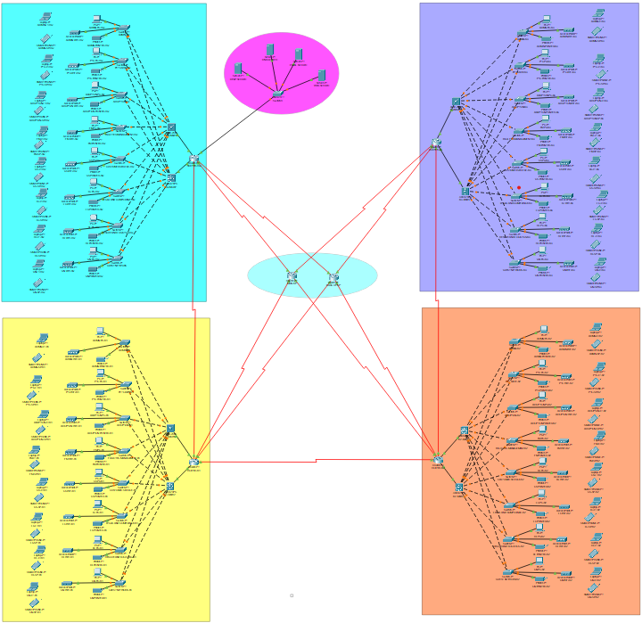
* **Subnetting**

|  |  |  |  |  |
| --- | --- | --- | --- | --- |
| **IP ADDRESSING MAIN HQ - Base Network: 192.168.100.0** | | | | |
| **Department** | **Network Address** | **Subnet Mask** | **Host Address Range** | **Broadcast Address** |
| Administration | 192.168.100.0 | 255.255.255.192/26 | 192.168.100.1 to 192.168.100.62 | 192.168.100.63 |
| Pet Care | 192.168.100.64 | 255.255.255.192/26 | 192.168.100.65 to 192.168.100.126 | 192.168.100.127 |
| Adoption Services | 192.168.100.128 | 255.255.255.192/26 | 192.168.100.129 to 192.168.100.190 | 192.168.100.191 |
| Facilities Management | 192.168.100.192 | 255.255.255.192/26 | 192.168.100.193 to 192.168.100.254 | 192.168.100.255 |
| Customer Service | 192.168.101.0 | 255.255.255.192/26 | 192.168.101.1 to 192.168.101.62 | 192.168.101.63 |
| Legal and Compliance | 192.168.101.64 | 255.255.255.192/26 | 192.168.101.65 to 192.168.101.126 | 192.168.101.127 |
| Rescue and Logistics | 192.168.101.128 | 255.255.255.192 /26 | 192.168.101.129 to 192.168.101.190 | 192.168.101.191 |
| Guest Network | 192.168.101.192 | 255.255.255.192 /26 | 192.168.101.193 to 192.168.101.254 | 192.168.101.255 |

|  |  |  |  |  |
| --- | --- | --- | --- | --- |
| **IP ADDRESSING BRANCH 1** | | | | |
| **Department** | **Network Address** | **Subnet Mask** | **Host Address Range** | **Broadcast Address** |
| Administration | 192.168.102.0 | 255.255.255.224/27 | 192.168.102.1 to 192.168.102.30 | 192.168.102.31 |
| Pet Care | 192.168.102.32 | 255.255.255.224/27 | 192.168.102.33 to 192.168.102.62 | 192.168.102.63 |
| Adoption Services | 192.168.102.64 | 255.255.255.224 /27 | 192.168.102.65 to 192.168.102.94 | 192.168.102.95 |
| Facilities Management | 192.168.102.96 | 255.255.255.224 /27 | 192.168.102.97 to 192.168.102.126 | 192.168.102.127 |
| Customer Service | 192.168.102.128 | 255.255.255.224 /27 | 192.168.102.129 to 192.168.102.158 | 192.168.102.159 |
| Legal and Compliance | 192.168.102.160 | 255.255.255.224 /27 | 192.168.102.161 to 192.168.102.190 | 192.168.102.191 |
| Rescue and Logistics | 192.168.102.192 | 255.255.255.224 /27 | 192.168.102.193 to 192.168.102.222 | 192.168.102.223 |
| Guest Network | 192.168.102.224 | 255.255.255.224 /27 | 192.168.102.225 to 192.168.102.254 | 192.168.102.255 |

|  |  |  |  |  |
| --- | --- | --- | --- | --- |
| **IP ADDRESSING BRANCH 2** | | | | |
| **Department** | **Network Address** | **Subnet Mask** | **Host Address Range** | **Broadcast Address** |
| Administration | 192.168.103.0 | 255.255.255.224 /27 | 192.168.103.1 to 192.168.103.30 | 192.168.103.31 |
| Pet Care | 192.168.103.32 | 255.255.255.224 /27 | 192.168.103.33 to 192.168.103.62 | 192.168.103.63 |
| Adoption Services | 192.168.103.64 | 255.255.255.224 /27 | 192.168.103.65 to 192.168.103.94 | 192.168.103.95 |
| Facilities Management | 192.168.103.96 | 255.255.255.224 /27 | 192.168.103.97 to 192.168.103.126 | 192.168.103.127 |
| Customer Service | 192.168.103.128 | 255.255.255.224 /27 | 192.168.103.129 to 192.168.103.158 | 192.168.103.159 |
| Legal and Compliance | 192.168.103.160 | 255.255.255.224 /27 | 192.168.103.161 to 192.168.103.190 | 192.168.103.191 |
| Rescue and Logistics | 192.168.103.192 | 255.255.255.224 /27 | 192.168.103.193 to 192.168.103.222 | 192.168.103.223 |
| Guest Network | 192.168.103.224 | 255.255.255.224 /27 | 192.168.103.225 to 192.168.103.254 | 192.168.103.255 |

|  |  |  |  |  |
| --- | --- | --- | --- | --- |
| **IP ADDRESSING BRANCH 3** | | | | |
| **Department** | **Network Address** | **Subnet Mask** | **Host Address Range** | **Broadcast Address** |
| Administration | 192.168.104.0 | 255.255.255.224 /27 | 192.168.104.1 to 192.168.104.30 | 192.168.104.31 |
| Pet Care | 192.168.104.32 | 255.255.255.224 /27 | 192.168.104.33 to 192.168.104.62 | 192.168.104.63 |
| Adoption Services | 192.168.104.64 | 255.255.255.224 /27 | 192.168.104.65 to 192.168.104.94 | 192.168.104.95 |
| Facilities Management | 192.168.104.96 | 255.255.255.224 /27 | 192.168.104.97 to 192.168.104.126 | 192.168.104.127 |
| Customer Service | 192.168.104.128 | 255.255.255.224 /27 | 192.168.104.129 to 192.168.104.158 | 192.168.104.159 |
| Legal and Compliance | 192.168.104.160 | 255.255.255.224 /27 | 192.168.104.161 to 192.168.104.190 | 192.168.104.191 |
| Rescue and Logistics | 192.168.104.192 | 255.255.255.224 /27 | 192.168.104.193 to 192.168.104.222 | 192.168.104.223 |
| Guest Network | 192.168.104.224 | 255.255.255.224 /27 | 192.168.104.225 to 192.168.104.254 | 192.168.104.255 |

|  |  |  |  |  |
| --- | --- | --- | --- | --- |
| **ROUTERS AND MULTILAYER SWITCHES** | | | | |
| **Connection** | **Network Address** | **Subnet Mask** | **Host Range Address** | **Broadcast Address** |
| SERVER | 192.168.105.0 | 255.255.255.240/28 | 192.168.105.1 - 192.168.105.14 | 192.168.105.15 |
| ROUTERHQ - HQMSW1 | 192.168.105.16 | 255.255.255.252/30 | 192.168.105.17 - 192.168.105.18 | 192.168.105.19 |
| ROUTERHQ - HQMSW2 | 192.168.105.20 | 255.255.255.252/30 | 192.168.105.21 - 192.168.105.22 | 192.168.105.23 |
| ROUTERB1 - B1MSW1 | 192.168.105.24 | 255.255.255.252/30 | 192.168.105.25 - 192.168.105.26 | 192.168.105.27 |
| ROUTERB1 - B1MSW2 | 192.168.105.28 | 255.255.255.252/30 | 192.168.105.29 - 192.168.105.30 | 192.168.105.31 |
| ROUTERB2 - B2MSW1 | 192.168.105.32 | 255.255.255.252/30 | 192.168.105.33 - 192.168.105.34 | 192.168.105.35 |
| ROUTERB2 - B2MSW2 | 192.168.105.36 | 255.255.255.252/30 | 192.168.105.37 - 192.168.105.38 | 192.168.105.39 |
| ROUTERB3 - B3MSW1 | 192.168.105.40 | 255.255.255.252/30 | 192.168.105.41 - 192.168.105.42 | 192.168.105.43 |
| ROUTERB3 - B3MSW2 | 192.168.105.44 | 255.255.255.252/30 | 192.168.105.45 - 192.168.105.46 | 192.168.105.47 |
| ROUTERHQ-ROUTERB1 | 192.168.105.48 | 255.255.255.252/30 | 192.168.105.49 - 192.168.105.50 | 192.168.105.51 |
| ROUTERB1-ROUTERB2 | 192.168.105.52 | 255.255.255.252/30 | 192.168.105.53 - 192.168.105.54 | 192.168.105.55 |
| ROUTERB2-ROUTERB3 | 192.168.105.56 | 255.255.255.252/30 | 192.168.105.57 - 192.168.105.58 | 192.168.105.59 |

|  |  |
| --- | --- |
| **ROUTERS TO ISP** | |
| ROUTERHQ-MAIN ISP | 195.136.17.0/30 |
| ROUTERHQ-BP ISP | 195.136.17.4/30 |
| ROUTERB1-MAIN ISP | 195.136.17.8/30 |
| ROUTERB1-BP ISP | 195.136.17.12/30 |
| ROUTERB2-MAIN ISP | 195.136.17.16/30 |
| ROUTERB2-BP ISP | 195.136.17.20/30 |
| ROUTERB3-MAIN ISP | 195.136.17.24/30 |
| ROUTERB3-BP ISP | 195.136.17.28/30 |

**Economic Feasibility**

The economic feasibility of the proposed network infrastructure for the pet adoption center is a critical component of the overall project evaluation. This assessment involves a detailed cost analysis of the necessary devices and services required to implement and maintain a robust and efficient network. The table below outlines the estimated costs associated with key components, including routers, switches, multilayer switches, PCs, access points, internet service provider (ISP) fees, printers, and physical servers. These costs form the basis for determining the financial viability of the network plan, ensuring that the project is both sustainable and capable of delivering the intended benefits. By carefully analyzing these expenses, we can make informed decisions that align with the center's operational needs and budget constraints.

|  |  |
| --- | --- |
| **Device** | **Estimated Cost** |
| **Router** | ₱28,000 per unit |
| **Switch** | ₱15,000 per unit |
| **Multilayer Switch** | ₱25,000 per unit |
| **PC** | ₱25,000 per unit |
| **Access Point** | ₱5,000 per unit |
| **ISP (Internet Service Provider)** | ₱10,000 per month |
| **Printer** | ₱5,000 per unit |
| **Physical Server** | ₱65,000 per unit |

**Total Cost Per Branch**

|  |  |  |
| --- | --- | --- |
| **Total Cost Per Branch (not including physical server and ISP)** | | |
| **Device** | **No. of Unit** | **Total Cost** |
| **Router** | 1 per branch | ₱28,000 |
| **Switch** | 7 per branch | ₱105,000 |
| **Multilayer Switch** | 2 per branch | ₱50,000 |
| **PC** | 10 per branch | ₱250,000 |
| **Access Point** | 7 per branch | ₱35,000 |
| **Printer** | 3 per branch | ₱15,000 |
|  |  | **₱483,000** |

**Summary of Cost**

*ISP Cost:*

* Monthly = ₱20,000 per month (2 ISPs)
* Yearly = ₱240,000 per year (2 ISPs)

*Total Cost per branch* **=** ₱483,000

*4 Servers* **=** ₱260,000

*Total Cost for 4 Branches with servers (excluding ISP)* **= (**₱483,000 * 4) + ₱260,000

**=** ₱**2,192,000**

* **Schedule Feasibility (GANNT CHART)**

The Gantt chart in the image illustrates a project schedule across three months (May, June, and July), divided into weekly intervals.  
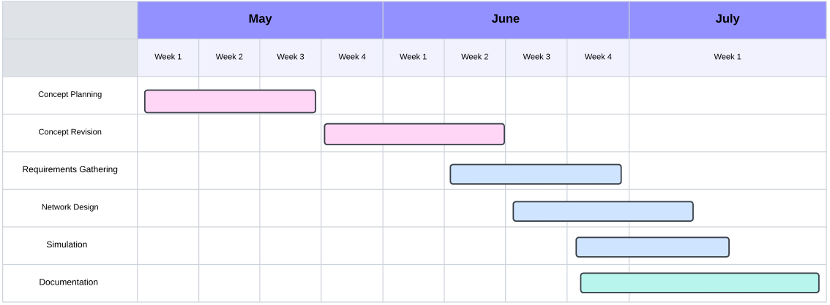

**Chapter V – FINDINGS, CONCLUSIONS AND RECOMMENDATIONS**

**Findings**

A robust network infrastructure was designed using Cisco Packet Tracer, incorporating the strategic placement of switches, routers, and access points to ensure full Wi-Fi coverage throughout the facility. Effective network security measures, including firewalls, VPNs, and antivirus software, were implemented. Servers and workstations were set up with appropriate specifications to ensure optimal performance and reliability, while peripheral devices like printers were seamlessly integrated into the network. Additionally, essential software for network management, security, and daily operations was installed and configured, ensuring the smooth and secure functioning of the entire system.

**Conclusions**

The designed network infrastructure meets the needs of the pet adoption center, ensuring reliable connectivity, security, and performance. Using Cisco Packet Tracer for simulation helped in pre-testing the network setup and identifying potential issues before implementation. The hardware and software setup was completed on time and within budget, with peripheral devices functioning correctly and integrated into the network. The implemented security measures provide strong protection against potential threats, and regular monitoring and updates ensure the network remains secure and performs optimally.

**Recommendations**

To ensure optimal network performance, it's essential to maintain regular monitoring to promptly identify and address any issues. Keeping all systems and software updated with the latest security patches is crucial for maintaining robust security. Considering additional measures like advanced intrusion detection systems (IDS) and conducting regular security audits can further bolster protection against potential threats. Planning for future scalability of the network infrastructure is vital for accommodating growth. Regularly assessing the adoption center's needs and updating the network plan accordingly ensures alignment with operational requirements. Detailed documentation of network setup, configurations, and procedures should be maintained to facilitate smooth operations. Additionally, for simulation, use a better router.